1. **Query all columns for all American cities in the CITY table with populations larger than 100000. The CountryCode for America is USA.**

**The CITY table is described as follows:**

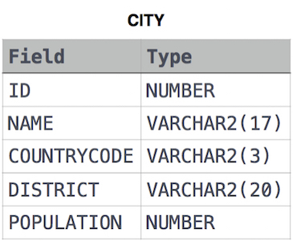

**SELECT *FROM CITY WHERE POPULATION>100000 AND COUNTRYCODE="USA";**

1. **Query the NAME field for all American cities in the CITY table with populations larger than 120000. The CountryCode for America is USA.**

**The CITY table is described as follows:  
 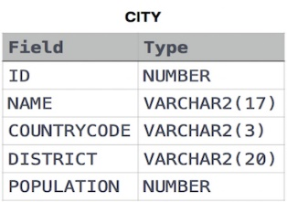**

**SELECT NAME FROM CITY WHERE POPULATION>120000 AND COUNTRYCODE="USA";**

1. Query all columns (attributes) for every row in the **CITY** tableThe **CITY** table is described as follows:  
    

**SELECT *FROM CITY;**

1. Query all columns for a city in **CITY** with the ID 1661.

The **CITY** table is described as follows:  
 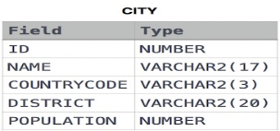

**SELECT *FROM CITY WHERE ID=1661;**

1. **Query all attributes of every Japanese city in the CITY table. The COUNTRYCODE for Japan is JPN.**

**The CITY table is described as follows:**  
 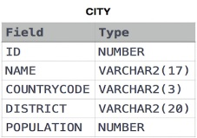

**SELECT *FROM CITY WHERE COUNTRYCODE="JPN";**